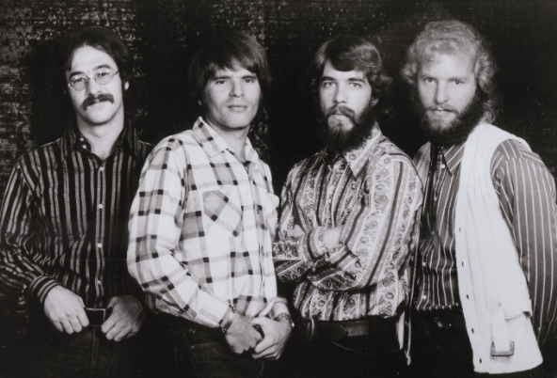
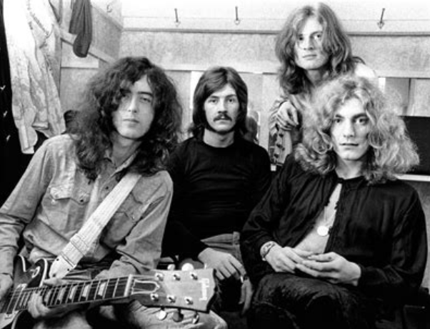
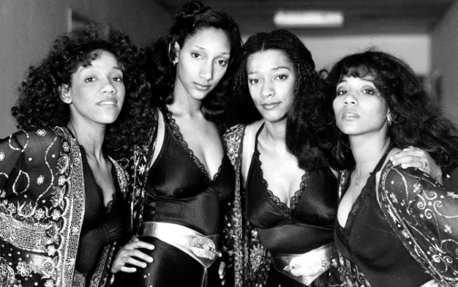

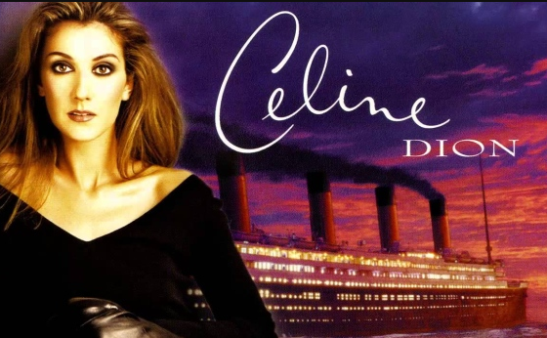
Misheard Lyrics

1. Creedence Clearwater Revival - Have You Ever Seen the Rain (1971)

https://www.youtube.com/watch?v=Gu2pVPWGYMQ (00:15)

What you hear: What the lyrics really are:
João botou melão no Gol Someone told me long ago

2) Led Zeppelin - Rock and Roll (1972)

https://www.youtube.com/watch?v=mwFqRB2FQu4 (02:20)

What you hear: What the lyrics really are:
Ceis são louco, ceis só Seems so long since we
votam no Lula walked in the moonlight

3) Sister Sledge - We are Family (1979)

https://www.youtube.com/watch?v=uyGY2NfYpeE (01:30)

What you hear: What the lyrics really are:
Just let me staple the vicar Just let me state for the record

4) Michael Jackson - You are not alone (1995)

https://www.youtube.com/watch?v=pAyKJAtDNCw (02:10)

What you hear: What the lyrics really are:
Your burgers are the best Your burdens I will bear

5) Celine Dion - My Heart will go on (1997)

https://www.youtube.com/watch?v=CUmOFqQRkco (01:20-01:30)

What you hear:
I believe that the hotdogs go on

What the lyrics really are:
I believe that the heart does go on

